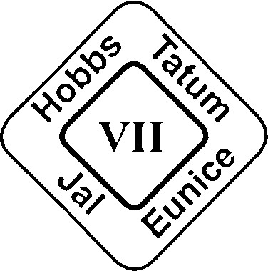
REGIONAL EDUCATION COOPERATIVE VII
April Williams, MS CCC-SLP - Executive Director
315 E. Clinton
Hobbs, New Mexico 88240
(575) 393-0755 (575) 393-0249 Fax
DWAIN HAYNES | GENE STRICKLAND | BRIAN SNIDER | GREG SLOVER
Superintendent | Superintendent | Superintendent | Superintendent
Eunice Public Schools | Hobbs Municipal Schools | Jal Public Schools | Tatum Municipal Schools

April 8, 2024

REGIONAL EDUCATION COOPERATIVE VII
315 E Clinton
Hobbs, NM 88240

Regional Education Cooperative VII (REC7) is accepting sealed written Bids for
external auditor services for the REC7's financial audits ending June 30, 2024,
2025 and 2026. Proposal should include estimated hours and cost for financial
statement audit, financial statement preparation and federal single audit. Bids
will be received by mail or hand-delivered at the above address, please mark
the envelopes as sealed bid 2425-1:

All BIDS must be received by April 24, 2024 at 3:00 pm

Scope of Work:

The Agency’s financial statements shall be prepared in accordance with the
following:

- Accounting and Financial Reporting Standards for Governmental Entities
Promulgated by the Governmental Accounting Standards Board;
- State Auditor’s Rule; and,
- Agency of Finance and Administration Requirements Related to Financial
Statement Presentation and Disclosure.

Audits of the Agency’s financial Statements shall cover the entire operations
of the Agency. They shall be conducted in conformity with the following
auditing standards and requirements:

- Generally Accepted Auditing Standards;
- Generally Accepted Government Auditing Standards issued by the Comp-
troller General of United States (Current Revision);
- Office of Management and Budget (OMB) Circular A-133;
- State Auditor’s Rule; and,
- Agency of Finance and Administration Audit Guidelines for New Mexico
State Agencies.

All Bids must meet the New Mexico PSAB Procedures for a financial audit of
a REC, and all necessary requirements for a Federal Single Audit. The Bid
must include the preparation of all financial statements and required docu-
mentation.

REGIONAL EDUCATION COOPERATIVES (RECS): For accounting purposes,
RECs are considered joint ventures in accordance with the GASB Codification of
Governmental Accounting and Financial Reporting Standards. A separate comp-
liance audit is required on the activities of RECs. The IPA shall provide a copy of
this report to the participating school districts and PED. REC’s will be tested for
compliance with PED Rule 6.23.3.7 NMAC through 6.23.3.12 NMAC. If applicable,
any on-behalf payments for benefits and salaries made by RECs for employees of
school districts should be accounted for in accordance with GASB Codification, N50.
135. The audit of each REC shall include a cash reconciliation schedule which
reconciles the cash balance of the previous year to the cash balance of the current
fiscal year. This schedule shall account for cash in the same categories used by the
REC on its monthly cash reports to PED. Any differences in cash from the RECs
financial records (bank statements) to the accounting records should be reconciled
with adjusting entries. The IPA shall write a finding if the reports submitted to PED
do not reconcile to the REC accounting records (2.2.2.12(C) NMAC).

To request additional information on auditing services please contact
Pat Jaco in writing to jacop@hobbsschools.net or the address above.

